Node.js Inroduction

- What is node.js?
→ Javascript is a functional programming language that is quite popular nowadays, this language is believed to be getting this place as it’s offering programmers to use this both in front-end & Backe-end development. To transform the js code in machine code, a runtime environment is needed. Browsers provide them for us. Basically, node.js is a runtime environment that extends google chrome’s V8 engine. Ryan Duhl is the creator of node.js. He used the chorme’s v8 and added his own C++ codes to make this powerful runtime environment. As this is nothing but a C++ program, it can be run in any machines that can be a sever or our own laptops, desktops.

- Single-threaded node.js yay or nay?
→ Node.js can serve clients with data from databases or files or from any
other servers, which is known as its I/O intensive works or aid clients with some mathematical calculations as well, which are known as CPU intensive tasks. I/O intensive tasks may take time and multiple clients can ask for service at a time, that time the I/O tasks get interesting for node.js. It uses libuv that internally uses the kernel’s multi-threading of the os of the machine or the server in which it’s being run(knows as Non Blocking), this is quite amazing. Then the response is given back to the client in asynchronous manner. However, if any bigger CPU task(s) is asked by the client, then node.js gives a bit less performance. That’s why CPU intensive tasks are not appreciated by node.js.

- Module and global objects
→ Browsers have window object, similar node.js has global object (Chrome’s v8 engine is only extracted not the full browser mechanism, Ryan Duhl added his own C++ flavour here).
→ Vanila javascript doesn’t have any modularity system. We can use the elements of one files one inside another easily. In vanila js, iife is used to chieve module system. Module is nothing but a .js file. But node.js has module system. Here, we can’t access any feature of another file without importing them as:
var/const/let variable = require(“filepath”)
N.B: The elements of the file that are used should be exported as:
module.export = variable/ {
name: variable1,
name: variable2
}
__dirname => Provides current working directory
__filename => Provides current working directory alongside filename
→ global object doesn’t provide with module or __dirname, __filename, require. They can be passed as the parameters of Module Wrapper function (The module is actually converted as iife internally by node.js).e.g:

function(exports, module, __dirname, __filename, require){
var a=5;
var b=10;
function test(){
console.log(‘Test’)
}
module.exports = {
a;
b;
test()
}
}, this function returns module.exports.
→ Own created modules, npm modules/libraries or some node.js core modules can be added to own project files.

- Server & Core modules
→ Likewise installing modules from node package manager (npm), some core modules are built-in there for node.js. They have some properties and methods inside them as well, which we can use in our application. Some commonly used of them are:

- path: This module often gives us path related information.
- os: This module often gives us various access to the os.
- fs: Used for file related opeartions (read from, write or append something into a file). Synchronous & Asynchronous both way can be used to use fs. In Asynchronous, a callback function is also passed as a parameter to control the sequence of program. errr, data are the two parameters passed to the callback function. e.g:
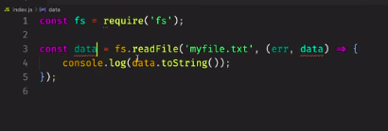

IV. events: This core module is used a lot, which returns a class when an event is emitted and it should be listened as well. As it returns a class the variable on which the importing is done starts with capital letter usually. An object should be created to the class. Emit() method fires the event and on() method listens it.
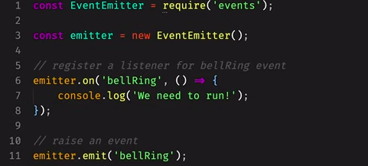
Parameters can be passed on event emits and later be listened.
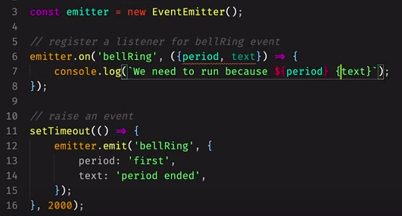
Events can be extended as well and listened on another file rather than on which it was emitted.

School.js (Emitted Even file):
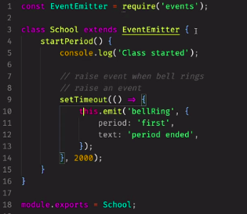

index.js (File on which the event is listened):
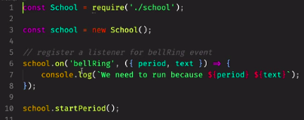

V. https: This is used to create servers. Events are created after instantiating this.
createServer() method is used to create the server that receives (req, res) parameters, which are request and response respectively. Server should be listened to a port as it’s an event and listen() method is used for that purpose.

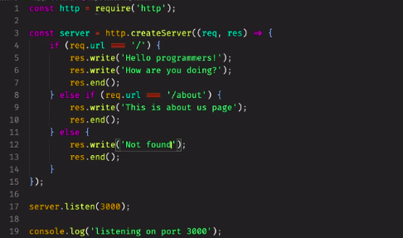

- Stream & Buffer
→ Data requested from clients or sent back to clients as stream. Stream is a flow that indicates not as full but as chunkwise data flow. Sum of some Buffers (Parts of data) form a stream. Buffer is an object, when it is full, it’s sent further.
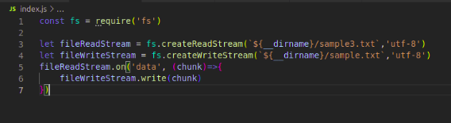
Data can be read as a stream or written as well, it doesn’t let the client wait for the full data to be transmitted rather it passes as a stream.
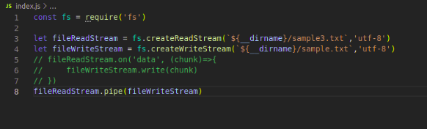
Pipe can also be used to do the upstated operation.

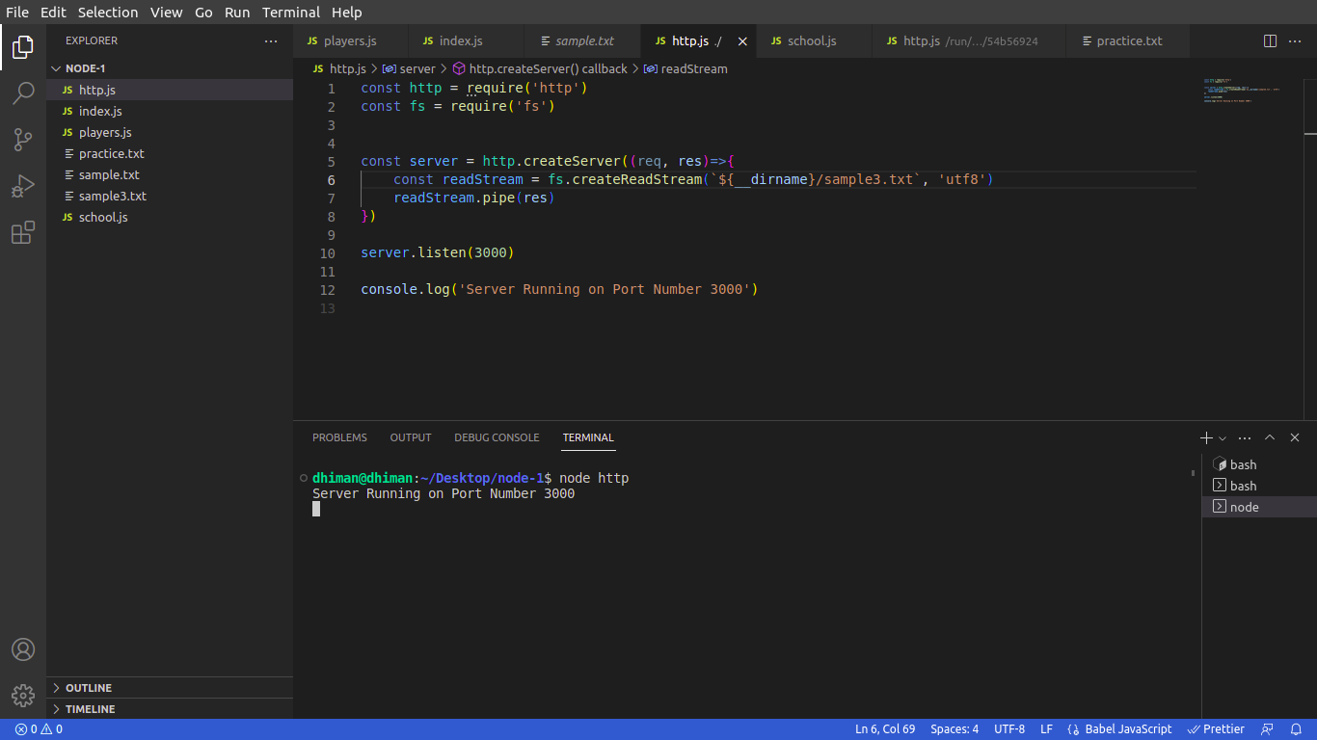
As a server, to read data from a file and give the response back, we can write as:
To give a response as per client request in forms, we can the use below snippet.
Here, req & res both listens for events. At first, for chunk of data it req listens data event and if the data fully comes, it listens end event. Chunks are concatted
into an array using the Buffer object.
